Answer Key - My Language Homework – Q4:2
Monday | Tuesday | Wednesday | Thursday
Circle the words that need to be capitalized.  I got so much candy on Valentine’s Day. | Which word could be found on this page of a dictionary?  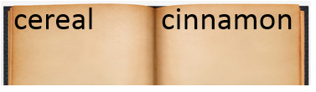  copy  crunch  chew | Split the compound word into parts. What does it mean?  skateboard  a board you can skate on. | Which definition matches the underlined word? 1  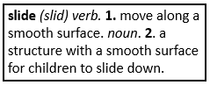  I am going to slide down the big hill.
What does the underlined word mean? Use the clues in the sentence to help you.  He rummaged through his bedroom looking for his lost toy.  searched/looked | Highlight the clue that helped you find the meaning of the word rummaged.  He rummaged through his bedroom looking for his lost toy. | What two words make each contraction?  let’s let us  mustn’t must not | Fill in the missing plural noun.  The women (woman) rested on the beach.
Fill in the missing past tense verb.  The birds flew (fly) over our house. | Which word best completes the sentence?  ourselves, themselves, itself  The cat cleaned ________ yesterday. | Is the language below formal or informal?  Welcome to the Art Museum. | Underline the possessive noun.  My pencil’s eraser is missing.
The prefix uni means one, so the word unify means…  to join together in one group | The prefix bi means two, so the word bicolor means…  having two colors | The prefix tri means three, so the word triangle means…  a shape with 3 sides | The root port means carry, so the word transport means…  to carry something somewhere
Is the underlined word an adjective or adverb?  She angrily closed the door. | Fill in the blank with an adjective.  The red ball rolled down the street. | Circle the words that mean the same as pretty.  cute  unpleasant  ugly  beautiful | Which word from yesterday’s list means the prettiest?  beautiful
Underline the collective noun in the sentence.  The band played at the football game. | Underline the collective noun in the sentence.  My family is the best! | Underline the collective noun in the sentence.  My mom works for a big company. | Underline the collective noun in the sentence.  The farmer has a herd of cattle.
Write the meaning of the prefix in-.  not | Make a list of words that begin with in-.  incorrect  invisible  incredible | What does the word incorrect mean?  not correct | What does the word inactive mean?  not active

