Answer Key - My Language Homework – Q3:4
Monday | Tuesday | Wednesday | Thursday
Circle the words that need to be capitalized.  I got a milkshake at Checkers. | Which word could be found on this page of a dictionary?  look  lucky  leaf | Circle the words that need to be capitalized.  Let’s drive through the Blue Ridge Mountains. | Which definition matches the underlined word? 1  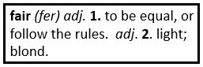  I am going to be fair and give you each one cookie.
What does the underlined word mean? Use the clues in the sentence to help you.  Ava was eager for her birthday party to finally begin.  excited | Highlight the clue that helped you find the meaning of the word eager.  Ava was eager for her birthday party to finally begin. | Split the compound word into parts. What does it mean?  broomstick  a stick that is a broom | Split the compound word into parts. What does it mean?  snowball  a ball made of snow
Fill in the missing plural noun.  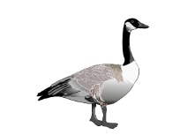  one goose  two geese | Write the two words that make the contraction.  hadn’t had not  I’ve I have | Fill in the missing plural noun.  All the women (woman) read the book. | Underline the possessive noun.  I broke the car’s window.
The prefix pre means before, so the word preplan means…  to plan before | The root port means to carry, so the word export means…  to carry out of a country | The suffix less means without, so the word fearless means…  without fear | The suffix ful means full of, so the word beautiful means…  full of beauty
Which word best completes the sentence?  myself, herself, himself  She can make ____________ lunch. | Fill in the missing past tense verb.  He drank (drink) all the water. | Which word best completes the sentence?  yourself, ourselves, itself  The chameleon can turn ____________ yellow. | Fill in the missing past tense verb.  She woke (wake) up early yesterday.
Fill in the missing word.  An adjective is a word that describes a noun | Fill in the missing word.  An adverb is a word that describes a verb. | Is the underlined word an adjective or adverb?  Emily’s beautiful painting is on the wall. | Is the underlined word an adjective or adverb?  She slowly ran around the track.

