Name ___________________________________
Room 17 Weekly Homework
*To be returned every morning for checking. Packet will be collected on Friday.
Monday  May 27, 2019 5-27-19  - Lang. Arts-Worksheet (optional)  - Reading -20 minutes (optional)  - Memorial Day Holiday—no school! | Tuesday  May 28, 2019 5-28-19  - Lang. Arts-Worksheet (optional)  - Math-Chapter 12, Lesson 4  - Reading -20 minutes
Wednesday  May 30, 2018 5-30-18  - Lang. Arts-Worksheet (optional)  - Reading -20 minutes  - Math- Chapter 12, Lesson 5 | Thursday  May 31, 2018 5-31-18  - Math-Chapter 12, Lesson 6  - Reading -20 minutes  - Writing Journal due Friday!

Math Vocabulary
angle | face
cone | fourths
cube | halves
cylinder | hexagon
edge | parallelogram
quadrilateral | pentagon

Homework through end of the year: We will be gradually letting up on the amount of homework until June—with no homework on the last week of school. You may notice that on some days, there will be no math, and spelling tic-tac-toe will be phasing its way out. However, I would like students to continue reading 20 minutes every night, in part because they should focus on completing their book talk projects.

Writing Journal
All students: respond to this question in your writing journal by Friday. Write at least 6 sentences.

What did you enjoy most about second grade? What did you like the least? Make sure you explain your reasons why you liked or didn’t like something.

Congratulations!
This is your last journal writing for the year!

Name: My Language Homework – Q2:5 (Review) Date:
Monday | Tuesday | Wednesday | Thursday
Circle the words that need to be capitalized.  Let’s go shopping at old navy today. | Which word could be found on this page of a dictionary?  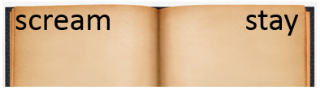  same  summer  sleep | Circle the words that need to be capitalized.  I love pringles potato chips. | Which definition matches the underlined word?  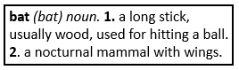  The bat lives in the cave.
What does the underlined word mean? Use the clues in the sentence to help you.  The heavy snow made the roads hazardous to drive on. | Highlight the clue that helped you find the meaning of the word hazardous.  The heavy snow made the roads hazardous to drive on. | Which compound word means “a boat that is also a house”?  houseboat  watermelon  homework | Split the compound word into parts. What does it mean?  heartbeat
Fill in the missing plural noun.  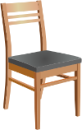  one chair  two ________________ | Fill in the missing plural noun.  All the ____________ (woman) wore big red hats. | Fill in the missing plural noun.  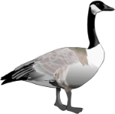  one goose  two ________________ | Fill in the missing plural noun.  My _____________ (foot) are so cold.
The base port means to carry, so the word portfolio means… | The prefix re means again, so the word review means… | The base port means to carry, so the word import means… | The prefix re means again, so the word reinvent means…
Write the two words that make the contraction.  won’t ___________  she’ll ___________ | Write the contraction.  should not ________  they are __________ | Write the two words that make the contraction.  he’s __________  what’s __________ | Write the contraction.  have not _________  does not _________
Fill in the missing word using an apostrophe.  The soccer ball belongs to Amy.  It is ___________ soccer ball. | Fill in the missing word using an apostrophe.  The bone belongs to the dog.  It is the ___________ bone. | Fill in the missing word using an apostrophe.  The pencil belongs to the teacher.  It is the ______________ paintbrush. | Fill in the missing word using an apostrophe.  The book belongs to Josh.  It is _________________ book.

