Answer Key - My Language Homework – Q2:5
Monday | Tuesday | Wednesday | Thursday
Circle the words that need to be capitalized.  Let’s go shopping at Old Navy today. | Which word could be found on this page of a dictionary?  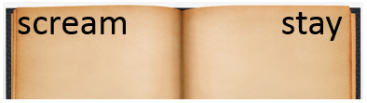  same  summer  sleep | Circle the words that need to be capitalized.  I love Pringles potato chips. | Which definition matches the underlined word? 2  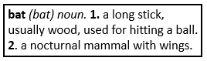  The bat lives in the cave.
What does the underlined word mean? Use the clues in the sentence to help you.  The heavy snow made the roads hazardous to drive on.  unsafe | Highlight the clue that helped you find the meaning of the word hazardous.  The heavy snow made the roads hazardous to drive on. | Which compound word means “a boat that is also a house”?  houseboat  watermelon  homework | Split the compound word into parts. What does it mean?  heartbeat  the beating sound of a heart
Fill in the missing plural noun.  one chair  two chairs | Fill in the missing plural noun.  All the women (woman) wore big red hats. | Fill in the missing plural noun.  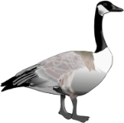  one goose  two geese | Fill in the missing plural noun.  My feet (foot) are so cold.
The base port means to carry, so the word portfolio means…  a case for carrying papers | The prefix re means again, so the word review means…  to view again | The base port means to carry, so the word import means…  to carry into a country | The prefix re means again, so the word reinvent means…  to invent again
Write the two words that make the contraction.  won’t will not  she’ll she will | Write the contraction.  should not shouldn’t  they are they’re | Write the two words that make the contraction.  he’s he is  what’s what is | Write the contraction.  have not haven’t  does not doesn’t
Fill in the missing word using an apostrophe.  The soccer ball belongs to Amy.  It is Amy’s soccer ball. | Fill in the missing word using an apostrophe.  The bone belongs to the dog.  It is the dog’s bone. | Fill in the missing word using an apostrophe.  The pencil belongs to the teacher.  It is the teacher’s paintbrush. | Fill in the missing word using an apostrophe.  The book belongs to Josh.  It is Josh’s book.

