Answer Key - My Language Homework – Q2:2
Monday | Tuesday | Wednesday | Thursday
Add ending punctuation to the sentence.  What time should we leave? | Is the underlined noun Singular or Plural?  My cats love to play with yarn. | Add ending punctuation to the sentence.  I would like to buy some gum at the store. | Underline the nouns in the sentence.  I use crayons to draw pictures.
Is the underlined verb Past, Present, or Future tense?  My friend and I played after school. | Write an adjective to describe the cookie.  yummy | Underline the verb in the sentence.  My aunt will drive me to school tomorrow. | Circle the adjective in the sentence.  Her car is small and red.
Circle the words that need to be capitalized.  My friend lives in Canada. | Which word could be found on this page of a dictionary?  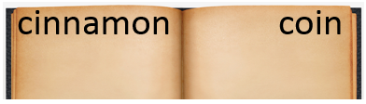  car  cucumber  clean | Circle the words that need to be capitalized.  We are going to light fireworks on New Year’s Eve. | Which definition matches the underlined word? 2  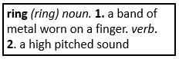  You can ring the doorbell to see if anyone is home.
What does the underlined word mean? Use the clues in the sentence to help you.  I drank a huge glass of water because I was so parched.  thirsty | Highlight the clue that helped you find the meaning of the word parched.  I drank a huge glass of water because I was so parched. | Which compound word means “the light from the moon”?  footprint  sunshine  moonlight | Split the compound word into parts. What does it mean?  sunshine  the light, or shine, coming from the sun.
Fill in the missing plural noun.  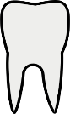  one tooth  two teeth | Fill in the missing plural noun.  The four geese (goose) flew over the pond. | Fill in the missing plural noun.  one child  two children | Fill in the missing plural noun.  The farmer had to gather all of his sheep (sheep) before the storm.
Write the meaning of the prefix re-  again or back | Make a list of words that start with re-.  rebuild  rewind  repaint | What does the word reread mean?  to read again | What does the word rewrite mean?  to write again

