Answer Key - My Language Homework – Q1:4
Monday | Tuesday | Wednesday | Thursday
Add ending punctuation to the sentence.  Stop that right now! | Is the underlined noun Singular or Plural?  The birds are in the tree. | Add ending punctuation to the sentence.  When does the movie start? | Underline the nouns in the sentence.  Put your cup on the table.
Is the underlined verb Past, Present, or Future tense?  My grandma will visit me next week. | Underline the verb in the sentence.  Emily jumped over the puddle. | Is the underlined verb Past, Present, or Future tense?  I watched the show. | Underline the verbs in the sentence.  The students ran and played at recess.
Write an adjective to describe the bike.  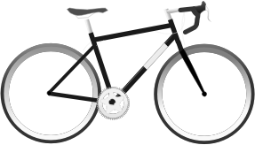  fast  answers will vary | Circle the adjective in the sentence.  The three dogs ran away. | Write an adjective to describe the piece of pie.  delicious  answers will vary | Circle the adjective in the sentence.  David’s shoes are old.
Circle the words that need to be capitalized.  It is hot in Texas. | Circle the words that need to be capitalized.  Jason went to Petsmart to buy some dog food. | Circle the words that need to be capitalized.  On Columbus Day, we are going to visit the lake. | Circle the words that need to be capitalized.  There are a lot of peaches in Georgia.
Circle the compound words.  airplane  waffle  anytime  piolet  bedroom  because | Which compound word means “a room for your bed”?  bedroom | Split the compound word into parts. What does it mean?  newspaper  a paper that gives the news. | Split the compound word into parts. What does it mean?  airshow  a show in the air
Circle the word that is spelled incorrectly?  You did a grat job.  (great) | Which word could be found on this page of a dictionary?  lunch  laugh  lift | Circle the word that is spelled incorrectly?  She reads a new book evry week.  (every) | Which word could be found on this page of a dictionary?  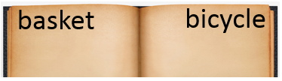  bench  bone  bump

