Answer Key - My Language Homework – Q1:6
Monday | Tuesday | Wednesday | Thursday
Add ending punctuation to the sentence.  My favorite season is summer. | Is the underlined noun Singular or Plural?  My fingers are freezing. | Add ending punctuation to the sentence.  What is your favorite season? | Underline the nouns in the sentence.  Put on your gloves and hat.
Is the underlined verb Past, Present, or Future tense?  We will see you next time. | Write an adjective to describe the coffee.  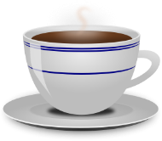  hot  answers will vary | Underline the verb in the sentence.  She tasted the pizza. | Circle the adjective in the sentence.  The hot pizza burned her mouth.
Circle the words that need to be capitalized.  Emma drove to Alabama to see her family. | Circle the words that need to be capitalized.  All toys are on sale at Walmart today. | Circle the words that need to be capitalized.  We are going to Disney World this summer. | Circle the words that need to be capitalized.  My favorite holiday is Christmas.
Circle the compound words.  everyday  reading  outside  slide  everywhere  playground | Which compound word means “ground used for playing”?  playground | Split the compound word into parts. What does it mean?  backyard  the yard in the back of your house. | Split the compound word into parts. What does it mean?  racehorse  a horse used for racing
Circle the word that is spelled incorrectly? Write the correct spelling.  My fathr plays baseball.  father | Which word could be found on this page of a dictionary?  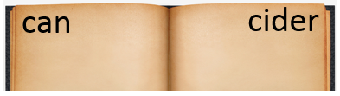  come  cucumber  cent | Circle the word that is spelled incorrectly? Write the correct spelling.  We live on planet Erth.  Earth | Which word could be found on this page of a dictionary?  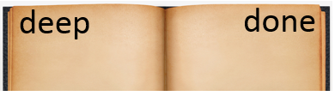  dig  danger  dump
Which definition matches the underlined word? 2  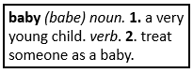  You shouldn’t baby your little brother. | Write a sentence using the word baby. Use the first definition.  answers may vary  ______________________  ______________________  ______________________ | Which definition matches the underlined word? 2  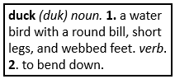  You should duck before the ball hits you. | Write a sentence using the word duck. Use the first definition.  answers may vary  ______________________  ______________________  ______________________

